**SMARTPHONE CONTROLLED ROBOT**

**INTRODUCTION :-**

The Linux-based operating system “Android” is designed by Google and is commonly used with Tablets and Smartphones. Today’s technological developments yield us to amalgamate the performance of smartphones with Robotics. Nowadays an electronic techie can easily make their own Robotic projects, which can be controlled with a soft touch on the smart phones screen by integrating different technologies with the Android Smart devices.

This Arduino project- Android Bluetooth Controlled Arduino Robot gets you a clean and clear idea about How to make an Android Bluetooth Controlled Arduino Robot. An android based Smartphone is used for controlling the Arduino Robot via Bluetooth and a User Interface app is used for interfacing with the Arduino UNO board.

The Block Diagram and the device parts used for Android Bluetooth Controlled Arduino Robot are explained below:

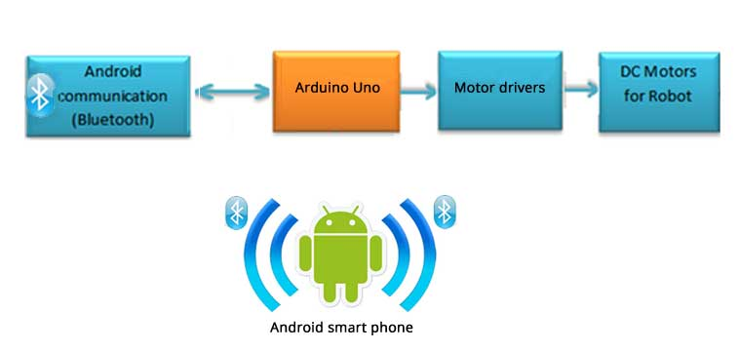

1. Android Device
2. Controller: Arduino UNO along with L293D IC
3. Bluetooth Module
4. DC Motors
5. Robot Physical Parts

**Android Device:**

Here we are using an android OS based smartphone for controlling the Arduino Robot. For that the Android OS must fulfill some conditions like: to have Bluetooth connectivity and an Android User Interface app for interfacing with the Arduino Robot. There is no doubt; today’s major smartphones have the Bluetooth facility. So the thing you need to care about is the Android user Interface app.  The Android User Interface app can be designed according to user’s needs. There are too many tools and kits available for designing such Android user Interface applications without much effort.

**Controller:**

Arduino UNO is used as the controller for making the Android Bluetooth Controlled Arduino Robot. Another benefit of using Arduino UNO with the Android smart phone is that there are many open source links and platforms available that provide full documents and resources which link between Android and Arduino.

**Bluetooth Module:**

A Bluetooth module is used for interfacing the Arduino Robot with the Android smartphone wirelessly. Here we are using Bluetooth HC-05 module.

Specifications of Bluetooth HC-05 module:

### Hardware Features

* Typical -80dBm sensitivity
* Up to +4dBm RF transmit power
* Low Power 1.8V Operation ,1.8 to 3.6V I/O
* PIO control
* UART interface with programmable baud rate
* With integrated antenna
* With edge connector

### Software Features

* Default Baud rate: 38400, Data bits:8, Stop bit:1,Parity:No parity, Data control: has.

Supported baud rate: 9600,19200,38400,57600,115200,230400,460800.

* Given a rising pulse in PIO0, device will be disconnected.
* Status instruction port PIO1: low-disconnected, high-connected;
* PIO10 and PIO11 can be connected to red and blue led separately. When master and slave

are paired, red and blue led blinks 1time/2s in interval, while disconnected only blue led blinks 2times/s.

* Auto-connect to the last device on power as default.
* Permit pairing device to connect as default.
* Auto-pairing PINCODE:”0000” as default
* Auto-reconnect in 30 min when disconnected as a result of beyond the range of connection.

**Motor Driver:**

For controlling the electrical motors used in the Arduino Robot, a motor driver IC - L293D Push-Pull Four Channel Driver IC- is used. For its features and specifications

**DC Motors for Robot:**

The DC motors are used for the movement of the Arduino Robot according to the input given by the user.

Circuit diagram of Android Bluetooth Controlled Arduino Robot with components Arrangements:

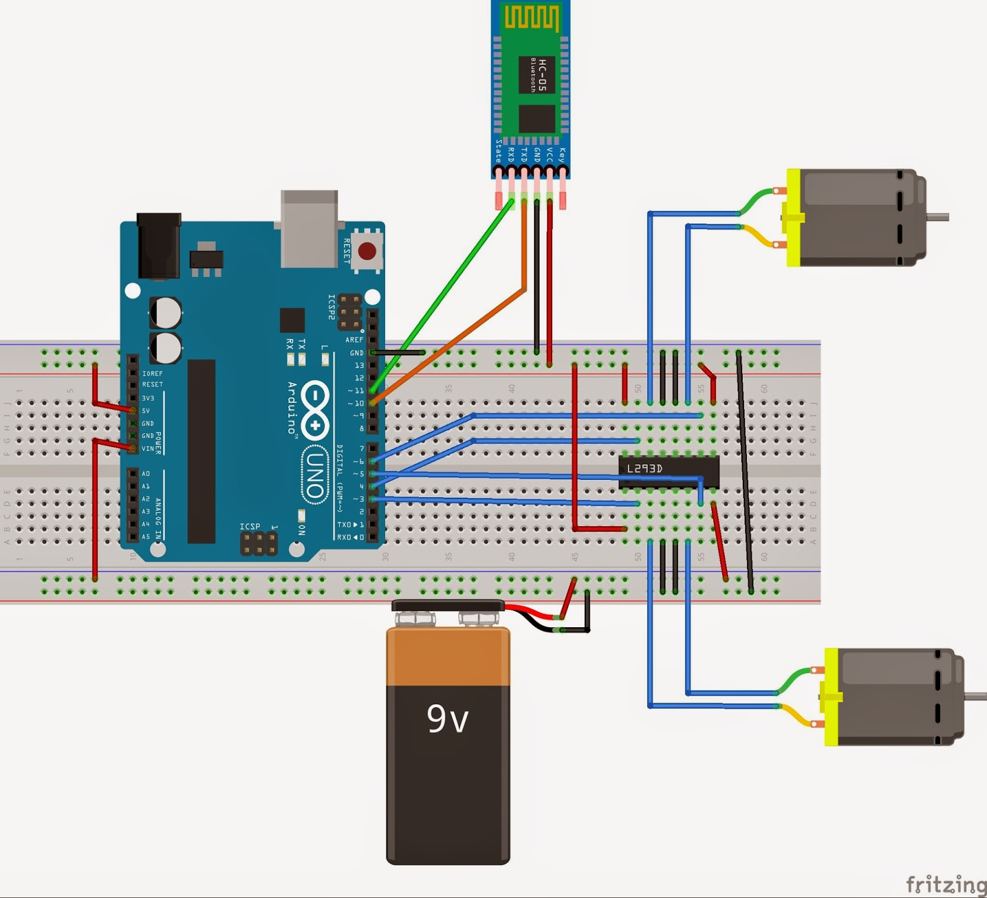

Electronic Components Required:

* Arduino UNO : 1 No.
* Bluetooth module HC-05 : 1 No.
* L293d IC : 1 No.
* Chassis
* Other Robotic Physical Parts

Applications of Android Bluetooth Controlled Arduino Robot:

* For industrial and commercial applications
* Can be used in remote area applications
* Helpful for mobility impaired persons
* As a toy
* For Pick and Place applications.

-By

1.Phanindra Edukulla

2nd ECE

JNTUHCEJ

2.Akhil Kumar Adepu

2nd ECE

JNTUHCEJ